30.10.2019 – DigiBP Ticino Group Notes

*Add Form to customer at the start (attached to E-mail to Unit Head)

*Add User information (from above form) to the database.

*Add DMN to decide feasibility

*Also add shortcut to jump the messaging between customer and unit head

*Add DMN to define project type and person

*Change “Register Project” into an automatic task

*Change “Order Reagents” into automatic task

*Centralize database

*Automate “Notify customer and record results”

*Automate the Cryotank Database

*DMN to take biopsy samples (Tatjana)

07.11.2019

-> Use NLP processing to read out information from e-mails to create a form or add information to form

-Watson IBM as option

-> Use Chatbot for Q&A to compliment the website

-> WebHook – Integromat – Google Sheets for the main database

-> Bar-code of the cryopreservation samples to check-in/check-out

-> Automated E-Mail to the customer with the XL datasheet of samples

-> Create a Slack communication channel to the customer

-> Error Handling

14.11.2019

-> Task for entering Data in DB (After Manual Task)

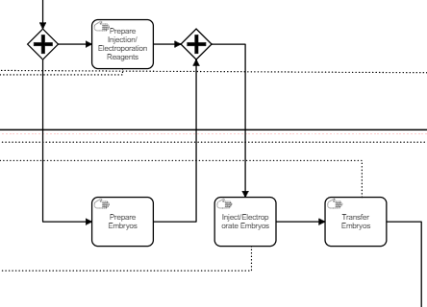

-> Remove Responsible Person from DMN

-> 5-10 days problem solution

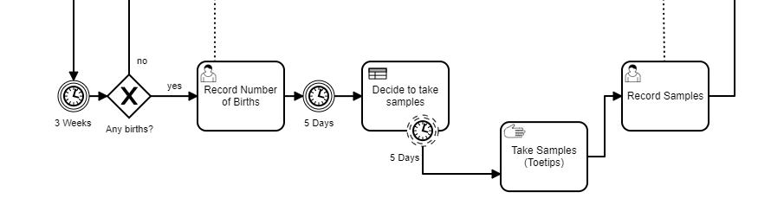

-> Plan and Order Mice -> 2 Tasks

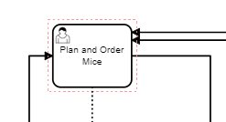

-> Service Task to analyse return form   
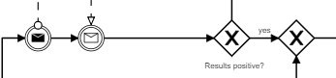

-> order reagents via integromat

-> barcode scanning function to-check (integromat)

**28.11.2019**

Changes made: Form was created, “Register Project” moved to follow registration of project.

Changes to DMN were made

To Do: The Integromat process for sending out the reagent order needs to be created:

Order (Camunda) -> Webhook (Integromat) -> Order Successful -> Timeout -> Send Request to REST-API -> (Return to Camunda) Message Catch Event

We need to create a format to send/receive the biopsy data to/from the customer:

Integromat or HTML

Barcode for cryopreservation samples? How to implement?